DATA ANALYSIS AND VISUALIZATION PROJECT REPORT
(Project Semester January-April 2025)

AGRICULTURAL PRODUCTION DASHBOARD(INDIA)

Submitted by : Hari Govind N

Registration No: 12406860

Programme : B.Tech CSE Section : 324PB
Course Code :INT 375

Under the Guidance of

Dr. Gargi Sharma
Discipline of CSE/IT

Lovely School of Computer Science

Lovely Professional University, Phagwara

CERTIFICATE

This is to certify that Hari Govind N bearing Registration no. 12406860 has completed INT 375 project titled, “Agricultural Production Dashboard(India)” under my guidance and supervision. To the best of my knowledge, the present work is the result of his/her original development, effort and study.

Signature and Name of the Supervisor Designation of the Supervisor
School of Computer Science Lovely Professional University Phagwara, Punjab.

Date: 19.04.2026
DECLARATION

I, Hari Govind N , student of B.Tech CSE (Program name) under CSE/IT Discipline at, Lovely Professional University, Punjab, hereby declare that all the information furnished in this project report is based on my own intensive work and is genuine.

Date: 22.04.2026 Signature

Registration No. 12406860 Name of the student : Hari Govind N

AKNOWLEDGEMENT

I would like to express my sincere gratitude to my project guide, Dr. Gargi Sharma, for her valuable guidance, continuous support, and encouragement throughout the completion of this project. Her insights and suggestions greatly helped in improving the quality of this work.
I would also like to thank the faculty members of the Lovely School of Computer Science, Lovely Professional University, for providing the necessary resources and knowledge required to carry out this project successfully.
I extend my heartfelt thanks to my friends and classmates for their support and cooperation during the project.
Lastly, I am grateful to my family for their constant motivation and encouragement, which helped me complete this project on time.
Hari Govind N
(Registration No: 12406860)

TABLE OF CONTENTS

- Introduction
- Source of Dataset
- Dataset Preprocessing
- Analysis on Dataset
  - Objective 1: Crop/Region-wise Performance Analysis
  - Objective 2: Productivity Efficiency Analysis
  - Objective 3: Growth Rate Analysis
  - Objective 4: Correlation Analysis
  - Objective 5: Contribution Analysis
- Conclusion
- Future Scope
- References

Introduction

Agriculture plays a vital role in the Indian economy, contributing significantly to national income and providing employment to a large section of the population. It serves as the backbone of rural livelihoods and is a primary source of income for millions of farmers across the country. India, being an agrarian economy, depends heavily on agricultural activities not only for food production but also for the supply of raw materials to various industries. The importance of agriculture extends beyond economic contribution, as it is closely linked to food security, poverty reduction, and overall socioeconomic development.
Over the years, Indian agriculture has undergone significant transformation due to technological advancements, government policies, and increased awareness among farmers. However, despite these developments, the sector continues to face several challenges such as unpredictable weather conditions, uneven distribution of resources, regional disparities, and fluctuating market demands. These challenges make it essential to analyze agricultural data in a systematic and efficient manner to identify patterns, trends, and areas of improvement.
With the rapid growth of data science and analytics, it has become possible to process and analyze large volumes of agricultural data effectively. Data-driven approaches allow for better understanding of agricultural performance and enable stakeholders to make informed decisions. By leveraging modern tools and technologies, raw and unstructured data can be transformed into meaningful insights that help in improving productivity, optimizing resource utilization, and enhancing overall efficiency in the agricultural sector.
In this context, data visualization plays a crucial role in simplifying complex datasets and presenting information in an easily understandable format. Visualization tools help in identifying hidden patterns, trends, and relationships within the data that may not be apparent through traditional methods of analysis. In this project, Python is used as the primary tool for data analysis and visualization. Libraries such as Pandas are used for data processing and manipulation, while Matplotlib and Seaborn are used to create clear and informative visualizations. These tools enable efficient analysis and graphical representation of agricultural data.
The primary objective of this project is to analyze agricultural production data across different states, districts, crops, and seasons in India. The dataset used in this study includes important attributes such as production, area of cultivation, yield, and time period. These attributes provide a comprehensive view of agricultural activities and enable detailed analysis of various factors influencing production.
The project focuses on examining how agricultural production varies across different regions of India. Since the country has diverse climatic conditions, soil types, and farming practices, production levels differ significantly from one region to another. By analyzing state-wise and district-wise data, it becomes possible to identify high-performing regions as well as areas that require improvement.
Another important aspect of this project is the analysis of production trends over time. Studying year-wise data helps in understanding whether agricultural production is increasing, decreasing, or fluctuating. Such trends are essential for evaluating the effectiveness of agricultural policies, technological interventions, and resource management strategies. They also help in predicting future production patterns and preparing for potential challenges.
Seasonal variation is another key factor considered in this analysis. Agricultural production in India is largely dependent on seasons such as Kharif, Rabi, and Zaid. Each season has its own characteristics in terms of crop types, climatic requirements, and productivity levels. Analyzing seasonal data provides insights into how different seasons contribute to overall production and highlights the importance of seasonal planning in agriculture.
In addition to production analysis, the project also examines the relationship between the area of cultivation and crop yield. While it is generally assumed that larger cultivation area leads to higher production, this is not always the case. Yield depends on several factors such as soil fertility, irrigation, use of fertilizers, and farming techniques. Understanding this relationship helps in identifying ways to improve productivity without necessarily increasing land usage.
To effectively analyze and present the data, various visualizations have been created using Python. These include bar charts, line graphs, and heatmaps that provide a clear and comprehensive view of the data. The visualizations help in understanding regional distribution, seasonal patterns, and trends over time. By presenting data in a structured and visually appealing manner, Python-based analysis makes it easier to interpret complex information and derive meaningful insights.
This project aims to bridge the gap between raw data and actionable knowledge by transforming agricultural data into informative visual representations. The insights obtained from this analysis can be valuable for various stakeholders, including policymakers, researchers, and farmers. Policymakers can use these insights to design effective agricultural policies and allocate resources efficiently. Researchers can analyze trends and patterns to develop innovative solutions, while farmers can make better decisions regarding crop selection and resource management.
Furthermore, this project demonstrates the practical application of data analytics using Python in solving real-world problems. It highlights the importance of integrating technology with traditional sectors such as agriculture to improve efficiency and sustainability. The skills and knowledge gained through this project are not only relevant for academic purposes but also have significant real-world applications.
In conclusion, the use of Python for data analysis and visualization in agriculture opens up new possibilities for improving productivity and decision-making. By analyzing agricultural production data using Python, this project provides a comprehensive understanding of various factors influencing agricultural performance in India. It emphasizes the importance of data-driven approaches in addressing challenges and ensuring sustainable agricultural development.

Source of Dataset

The dataset used in this project has been obtained from the official website of the **Directorate of Economics and Statistics (DES), Ministry of Agriculture and Farmers Welfare, Government of India (https:// aps.dac.gov.in).

This platform provides authentic agricultural statistics related to crop production, area, and yield across different states and districts of India.

The dataset includes key attributes such as:

- State
- District
- Crop
- Area
- Production
- Year

As the data is sourced from a government-authorized agricultural statistics portal, it ensures high reliability and accuracy. The dataset was further cleaned and processed before being used in Power BI for analysis and dashboard creation.
Dataset Preprocessing

Before performing analysis and visualization, the dataset was preprocessed to ensure data quality, accuracy, and consistency. Raw data collected from external sources often contains missing values, inconsistencies, duplicate entries, and formatting issues. If such data is used directly for analysis, it can lead to incorrect insights and misleading conclusions. Therefore, preprocessing is a crucial step in any data analysis project as it prepares the dataset for accurate and reliable interpretation.
The agricultural dataset used in this project contained multiple attributes such as state, district, crop, season, area, production, and year. Since the dataset was large and collected from real-world sources, it required thorough cleaning and transformation before being analyzed using Python.
The following preprocessing steps were carried out:

Handling Missing Values
One of the most common issues in real-world datasets is the presence of missing or null values. In this dataset, certain fields such as Season and Crop contained blank or undefined entries. These missing values were carefully analyzed and handled using Python’s Pandas library. Records with excessive missing information were removed where necessary, while in other cases missing values were replaced with appropriate placeholders such as “Unknown” using functions like fillna(). Handling missing values ensured that the dataset remained complete and prevented errors during analysis and visualization.

Removing Duplicates
Duplicate records can distort analysis results by over-representing certain data points. Therefore, the dataset was checked for duplicate entries using drop_duplicates() based on key attributes such as state, district, crop, and year. Identified duplicates were removed to eliminate redundancy and ensure that each record represented a unique data point. This step helped in maintaining the accuracy of aggregated values such as total production and average yield.

Data Cleaning
Data cleaning involves correcting inconsistencies and errors present in the dataset. In this project, inconsistencies such as spelling variations, inconsistent naming conventions, and incorrect entries were identified and corrected using string operations in Pandas. For example, variations in state or crop names were standardized using functions like str.strip() and str.lower(). This ensured that similar data points were not treated as separate categories during analysis. Proper data cleaning improved the overall reliability of the dataset.

Data Type Conversion
For effective analysis, it is essential that each column has the correct data type. In the dataset, columns such as Area, Production, and Year were converted into appropriate numerical formats using pd.to_numeric(). This allowed accurate calculations, aggregations, and comparisons. Ensuring correct data types prevented errors during analysis and improved computational efficiency.

Column Renaming and Standardization
To improve readability and usability, column names were simplified and standardized. Complex or unclear column names were replaced with meaningful labels using rename() and string formatting functions. This made it easier to work with the dataset and ensured better understanding of the data structure. Standardized naming conventions also helped maintain consistency throughout the analysis.

Filtering and Data Reduction
The dataset initially contained some irrelevant or unnecessary records that were not required for the analysis. These records were filtered out using conditional selection to focus only on meaningful and relevant data. Filtering helped in reducing dataset size, improving performance, and ensuring that the analysis remained aligned with the project objectives. It also helped in handling outliers and extreme values.

Data Transformation
After cleaning and preparing the dataset, additional transformations were performed to enhance analysis. The dataset was reshaped from wide format to long format using techniques such as column iteration and concatenation. New calculated fields such as efficiency (production per area) and growth rate were created using Pandas operations. These transformations enabled deeper analysis and supported effective visualization.

Handling Categorical Data
Categorical variables such as Season and Crop were reviewed and standardized to ensure consistency. Categories were organized and cleaned to avoid duplication and confusion. This ensured that visualizations such as charts and graphs displayed clear and meaningful groupings.

Ensuring Data Consistency
Consistency checks were performed across the dataset to ensure logical correctness. For instance, production values were validated against area and yield wherever applicable. Any anomalies or unrealistic values were identified and handled appropriately. Maintaining consistency ensured that the analysis results were reliable and trustworthy.

Overall, the preprocessing phase played a vital role in improving the quality of the dataset. By handling missing values, removing duplicates, cleaning inconsistencies, and transforming the data using Python, the dataset was prepared for accurate and efficient analysis. These steps ensured that the visualizations created using libraries such as Matplotlib and Seaborn were meaningful, reliable, and reflective of real-world agricultural patterns.
In conclusion, dataset preprocessing is an essential step in any data analysis project. It not only enhances data quality but also ensures that the insights derived are valid and actionable. The careful preprocessing carried out in this project using Python laid a strong foundation for effective visualization and analysis, ultimately contributing to the success of the agricultural study.
Analysis On Dataset

Objective 1: To Analyze Total Agricultural Production Across States

i. General Description
This objective focuses on examining how agricultural production is distributed across different states in India using Python-based data analysis. By aggregating production data, it helps in understanding regional variations and identifying states that contribute significantly to overall agricultural output.

ii. Specific Requirements
- Use groupby("state") in Pandas to aggregate production data
- Calculate total production using sum()
- Sort results using sort_values() to rank states
- Identify top-performing and low-performing states
Example approach:
state_prod = df.groupby("state")["production"].sum().reset_index()
state_prod = state_prod.sort_values(by="production", ascending=False)

iii. Analysis Results
The analysis revealed that a few states contribute significantly higher agricultural production compared to others, indicating regional dominance. These variations can be attributed to factors such as climatic conditions, soil fertility, irrigation facilities, and farming practices. On the other hand, some states showed comparatively lower production, highlighting areas that may require improvement in agricultural infrastructure and resource utilization.

iv. Visualization
The results were visualized using Python libraries such as Matplotlib and Seaborn:
- A bar chart was used to compare production across states
- Horizontal bars improved readability for large datasets
Example:
sns.barplot(x="production", y="state", data=state_prod.head(10))
These visualizations provided a clear understanding of state-wise production distribution and helped in identifying dominant contributors.

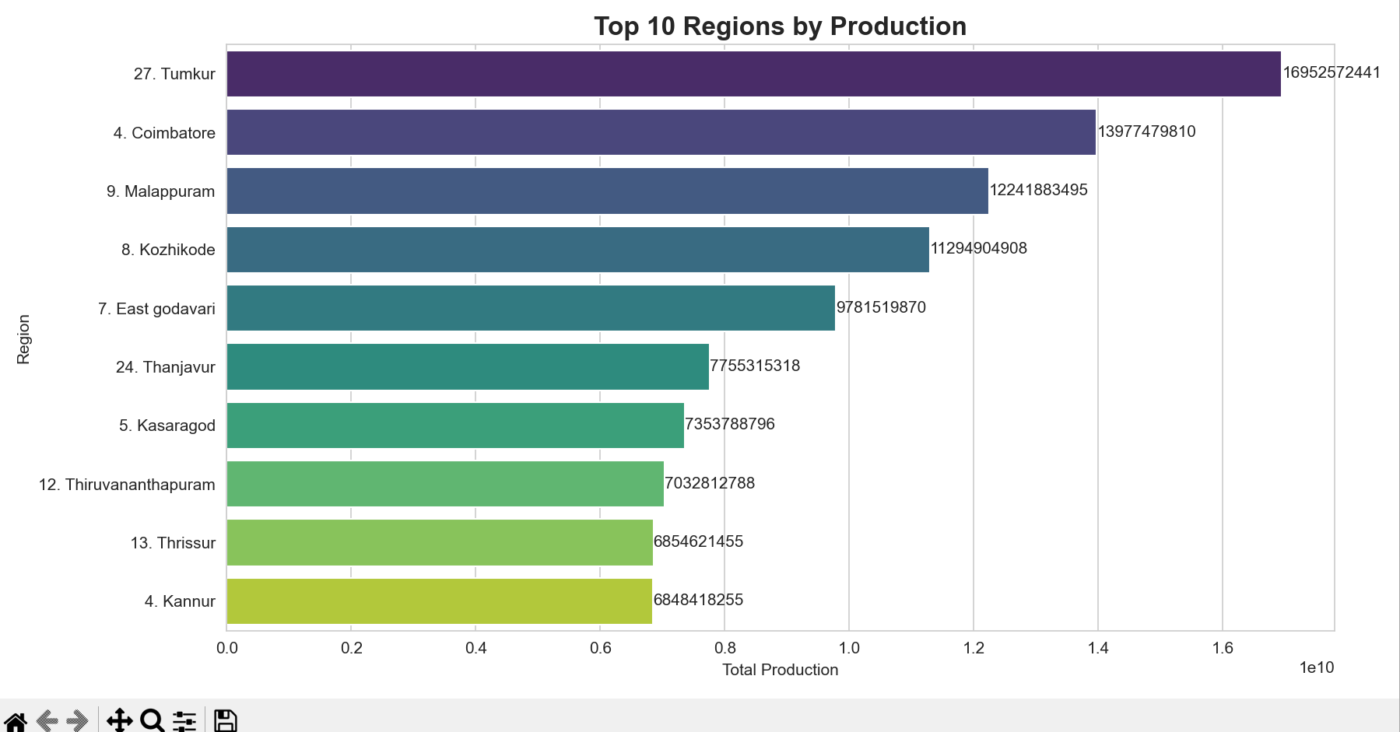

Objective 2: To Study Production Trends Over Different Years

i. General Description
This objective aims to analyze how agricultural production has changed over time using Python-based analysis. It helps in identifying patterns such as growth, decline, or fluctuations in production across different years.

ii. Specific Requirements
- Convert year data into numerical format
- Group data by year using groupby()
- Calculate total production using sum()
- Sort data chronologically to observe trends
Example approach:
yearly_prod = df.groupby("year")["production"].sum().reset_index()
yearly_prod = yearly_prod.sort_values(by="year")

iii. Analysis Results
The analysis showed fluctuations in production over the years, with certain periods exhibiting steady growth while others indicated slight declines. These variations may be influenced by factors such as climatic conditions, policy changes, and resource availability.

iv. Visualization
A line chart was used to display year-wise production trends, providing a clear view of how production has evolved over time.
Example:
sns.lineplot(x="year", y="production", data=yearly_prod)
plt.title("Year-wise Production Trend")
plt.show()

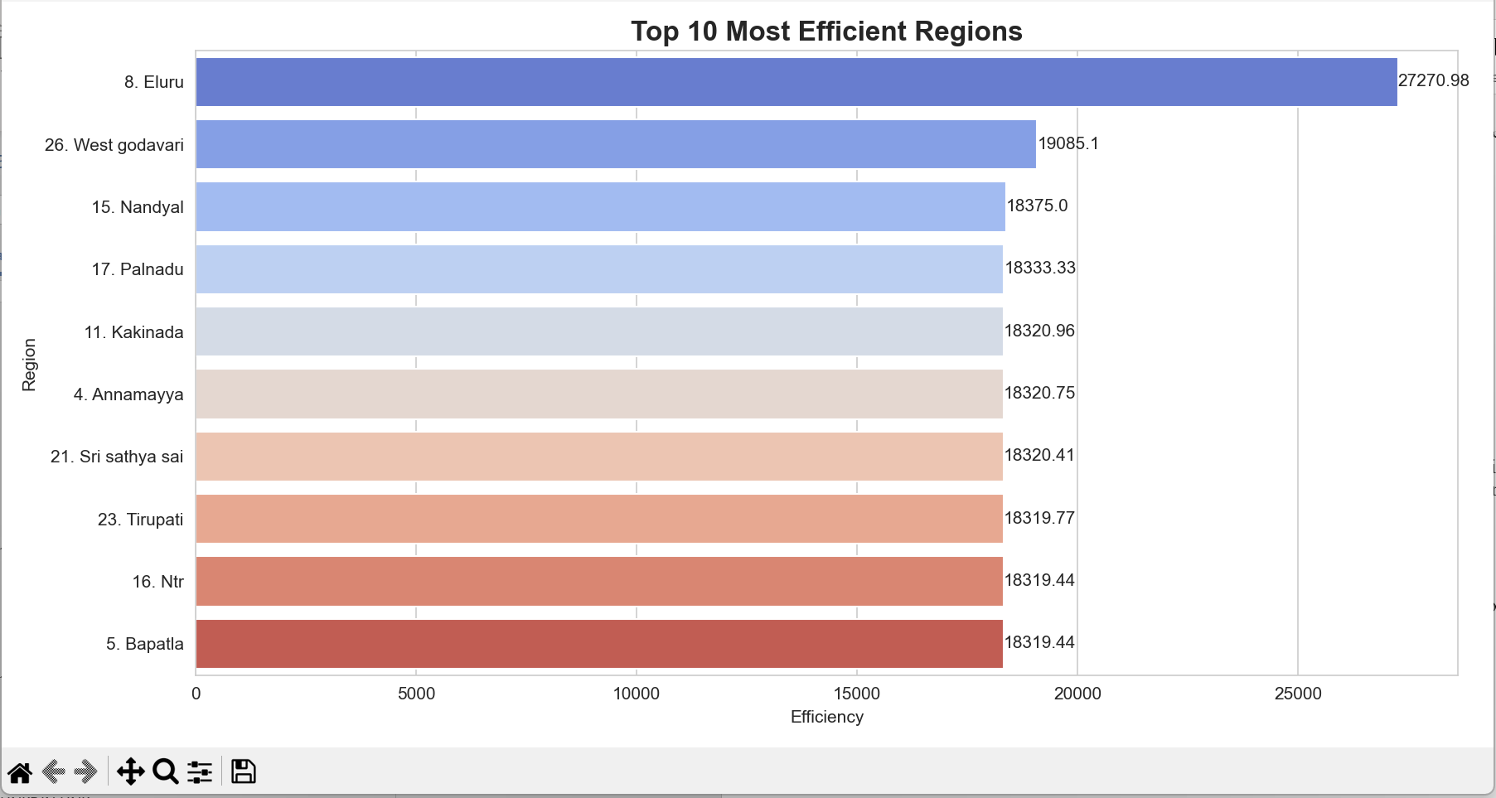

Objective 3: To Compare Production Across Different Seasons

i. General Description
This objective focuses on understanding how agricultural production varies across different seasons using Python-based analysis. It helps in identifying which seasons contribute the most to overall production.

ii. Specific Requirements
- Group data by season using groupby()
- Calculate total production using sum()
- Compare production across seasons such as Kharif, Rabi, and others
Example approach:
season_prod = df.groupby("season")["production"].sum().reset_index()

iii. Analysis Results
The analysis showed that certain seasons contribute more to total production than others, highlighting the importance of seasonal patterns in agriculture. These differences may be influenced by climatic conditions, crop types, and farming practices associated with each season.

iv. Visualization
A donut chart was used to represent the seasonal distribution of production, making it easier to compare the contribution of each season.
Example:
plt.pie(season_prod["production"], labels=season_prod["season"], autopct="%1.1f%%")
centre_circle = plt.Circle((0,0),0.70,fc='white')
fig = plt.gcf()
fig.gca().add_artist(centre_circle)
plt.title("Season-wise Production Distribution")
plt.show()

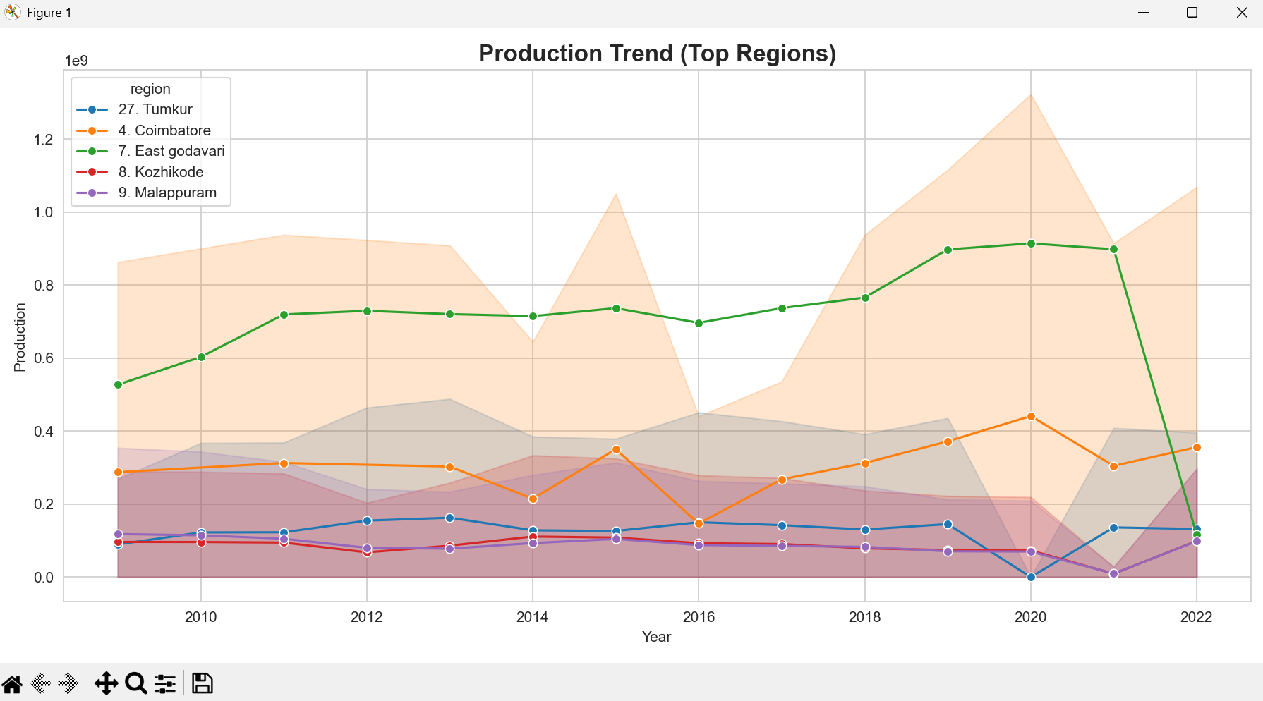

Objective 4: To Identify Top-Performing Regions and Districts

i. General Description
This objective aims to identify regions and districts with the highest agricultural production using Python-based analysis. It helps in understanding which areas contribute the most to overall production and highlights regional disparities.

ii. Specific Requirements
- Group data by region (or district if available) using groupby()
- Calculate total production using sum()
- Rank regions using sort_values()
- Extract top contributors using head()
Example approach:
region_prod = df.groupby("region")["production"].sum().reset_index()
top_regions = region_prod.sort_values(by="production", ascending=False).head(10)

iii. Analysis Results
The analysis identified a small number of regions as major contributors to agricultural production, indicating an uneven distribution of productivity. These top-performing regions likely benefit from better resources, favorable climatic conditions, and advanced farming practices, while other regions may require improvements.

iv. Visualization
A bar chart was used to highlight the top-performing regions, providing a clear comparison of production levels.
Example:
sns.barplot(x="production", y="region", data=top_regions)
plt.title("Top Performing Regions")
plt.show()
Additionally, a treemap can be used to represent hierarchical distribution (optional in Python using libraries like squarify).

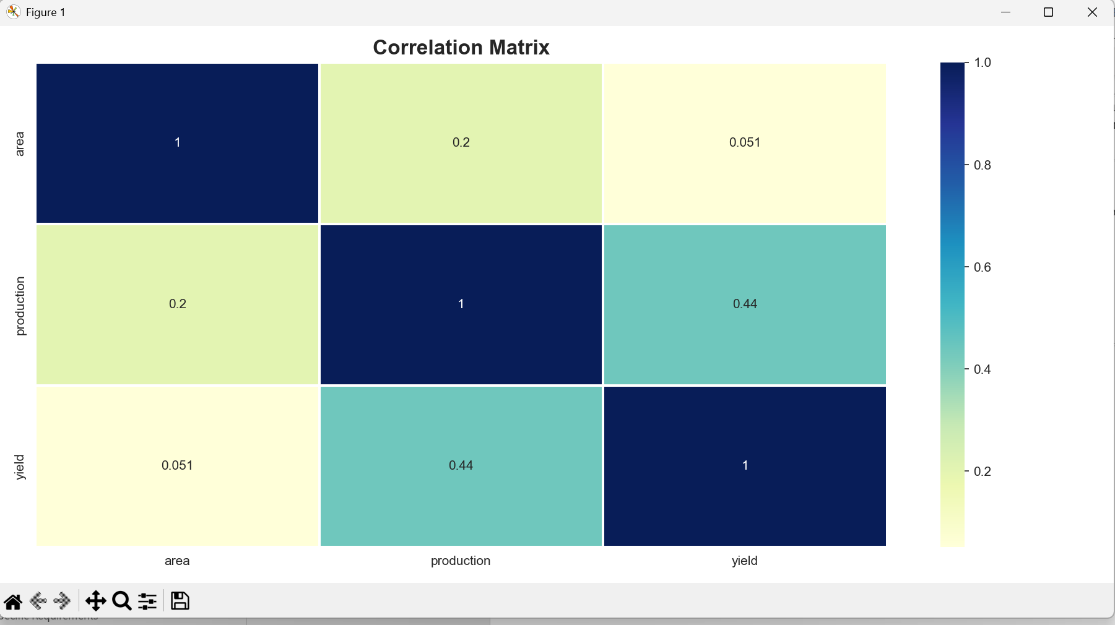

Objective 5: To Analyze the Relationship Between Area and Yield

i. General Description
This objective focuses on understanding how the area of cultivation affects crop yield using Python-based analysis. It helps in identifying whether larger cultivated areas lead to higher productivity or if other factors influence yield.

ii. Specific Requirements
- Select relevant columns: area and yield
- Analyze relationship using correlation and comparison
- Compute correlation using:
df[["area", "yield"]].corr()
- Compare values across regions if needed using groupby()

iii. Analysis Results
The analysis indicated that a higher cultivation area does not always result in higher yield. This suggests that yield is influenced by multiple factors such as soil quality, irrigation, fertilizers, and farming techniques rather than just land size.

iv. Visualization
A scatter plot and comparative charts were used to represent the relationship between area and yield, making it easier to observe patterns and correlations.
Example:
sns.scatterplot(x="area", y="yield", data=df)
plt.title("Area vs Yield Relationship")
plt.show()
Additionally, bar charts can be used to compare average yield across regions for better interpretation.

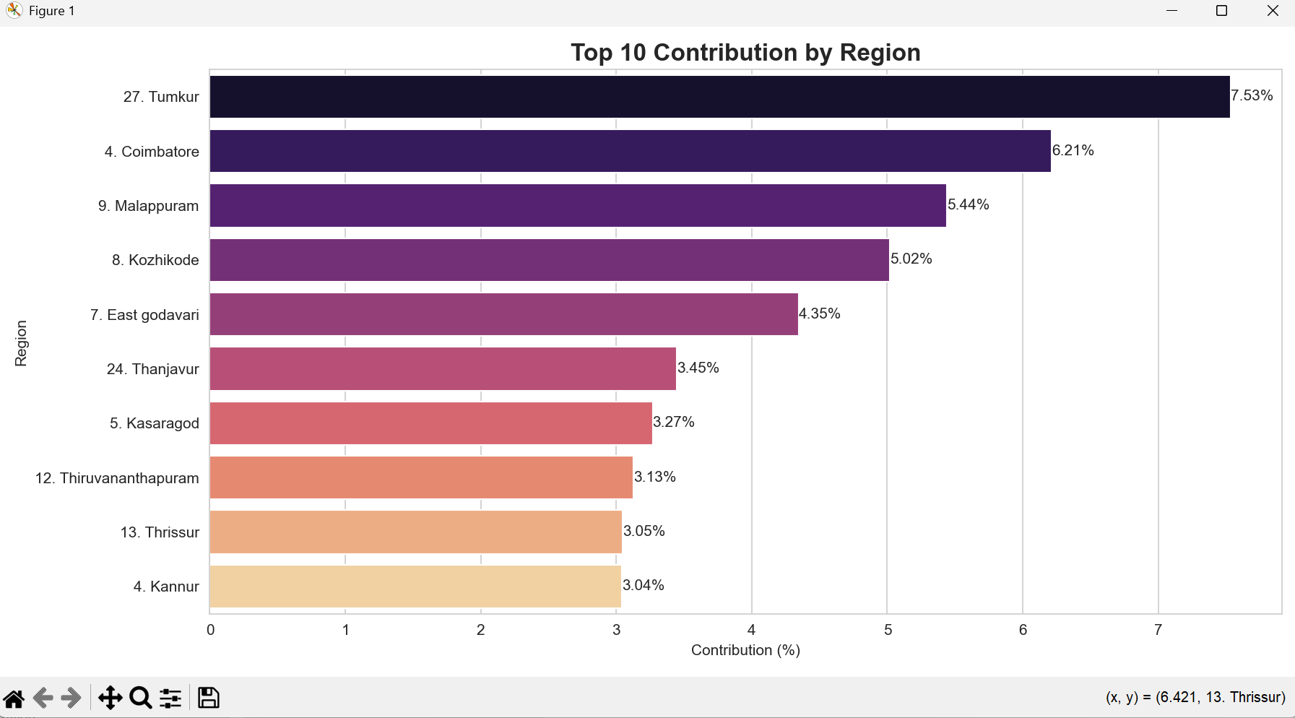
Conclusion
This project focused on the analysis of agricultural production data in India using modern data analysis and visualization techniques through Python. Agriculture, being a crucial sector of the Indian economy, requires systematic analysis of its patterns, trends, and performance to support informed decision-making and efficient resource management. The primary objective of this project was to transform raw agricultural data into meaningful and structured insights using Python libraries such as Pandas, Matplotlib, and Seaborn, enabling easier understanding of complex datasets.
The dataset used in this study included multiple important attributes such as state, district, crop type, season, area of cultivation, production, and year. Through systematic preprocessing and cleaning of the dataset, issues such as missing values, inconsistencies, and irrelevant entries were handled effectively. This ensured that the data used for analysis was accurate, reliable, and suitable for visualization.
One of the key findings of this project is that agricultural production in India is not uniformly distributed. Certain states and regions contribute significantly more to total production compared to others. This uneven distribution highlights the influence of factors such as soil quality, climatic conditions, irrigation facilities, and farming practices. Identifying these high-performing regions is essential for understanding best practices and improving agricultural output in lower-performing areas.
The analysis of production trends over the years revealed noticeable fluctuations. While some periods showed steady growth, others indicated a decline or stagnation in production levels. These variations may be influenced by factors such as weather conditions, policy changes, availability of resources, and technological advancements. Understanding these trends is important for predicting future production patterns and ensuring food security.
Seasonal analysis provided further insights into agricultural productivity. It was observed that certain seasons, such as Kharif and Rabi, contribute differently to total production. Seasonal dependency indicates the importance of timely rainfall, irrigation systems, and crop selection. This highlights the need for efficient seasonal planning and the adoption of advanced agricultural techniques to maximize productivity.
Another important aspect of this project was the identification of top-performing regions and districts. Using visualizations such as bar charts and comparative plots, it was possible to highlight regions that consistently contribute higher production. This kind of analysis is useful for policymakers and researchers to focus on regional strengths and address weaknesses in other areas.
The relationship between cultivated area and yield was also examined. It was observed that a larger area of cultivation does not always result in higher yield. This indicates that productivity depends not only on land availability but also on factors such as quality of seeds, use of fertilizers, irrigation methods, and technological support. This insight emphasizes the importance of efficient resource utilization rather than simply increasing cultivated land.
The use of Python in this project played a significant role in enhancing data interpretation. The analysis performed is structured, efficient, and visually informative. It allows users to explore data across different years, seasons, and regions, and to understand trends clearly through graphical representations. The use of visualization techniques such as bar charts, line graphs, scatter plots, and heatmaps made the analysis more comprehensive and easier to interpret.
Furthermore, the project demonstrates the importance of data-driven decision-making in agriculture. By converting raw data into actionable insights, stakeholders such as farmers, government authorities, and researchers can make informed decisions to improve productivity and sustainability. Effective visualization helps in identifying patterns, detecting anomalies, and understanding trends more clearly.
This project also highlights the practical application of data analytics using Python in real-world scenarios. It showcases how theoretical knowledge can be applied to solve real-life problems and derive meaningful conclusions. The skills developed during this project, such as data cleaning, transformation, visualization, and interpretation, are highly valuable in the field of data science and analytics.
In conclusion, the agricultural data analysis carried out in this project successfully achieves its objectives by providing clear, structured, and insightful analysis of agricultural production in India. It enhances understanding of agricultural patterns and demonstrates the effectiveness of Python as a tool for data analysis and visualization. The insights gained from this project can contribute to better planning, improved productivity, and more efficient resource management in the agricultural sector.
Overall, this project serves as a strong example of how data analytics can be used to address real-world challenges and support sustainable development. It reinforces the idea that with the right tools and techniques, data can be transformed into valuable insights that drive informed decision-making.
knowledge that drives progress and innovation.

Future Scope
This project presents a comprehensive analysis of agricultural production data in India using Python-based data analysis and visualization techniques. While the current analysis provides meaningful insights into patterns, trends, and regional performance, there is significant scope for further enhancement to make the project more advanced, accurate, and impactful.
One of the major areas for future improvement is the integration of real-time data. Currently, the analysis is based on historical datasets, which provide valuable insights but may not reflect current conditions. By incorporating real-time or frequently updated datasets from official government sources using APIs or automated data pipelines, the analysis can become more dynamic and relevant. This would enable users to monitor ongoing agricultural activities and make timely decisions.
Another important enhancement would be the inclusion of additional variables that influence agricultural productivity. Factors such as rainfall, temperature, humidity, soil type, irrigation facilities, and fertilizer usage play a crucial role in determining crop yield. Integrating these variables into the dataset using Python would allow for a more comprehensive and multi-dimensional analysis, helping to identify key factors affecting production more accurately.
The project can also be extended by implementing predictive analytics using machine learning techniques. By applying models such as regression analysis, time series forecasting, or classification algorithms using libraries like Scikit-learn, future agricultural production trends can be predicted. This would help farmers, policymakers, and stakeholders anticipate changes and make better decisions.
In addition, the project can be enhanced with more advanced and interactive visualizations using Python libraries such as Plotly or Dash. These tools allow the creation of interactive dashboards where users can explore data dynamically through filters, hover effects, and drill-down analysis. This would significantly improve user experience and make the analysis more engaging and insightful.
Another potential area of expansion is the inclusion of crop-wise profitability and economic analysis. Instead of focusing only on production and yield, the project can incorporate factors such as cost of cultivation, market prices, and profit margins. This would provide a financial perspective on agriculture and help farmers make better decisions regarding crop selection and resource allocation.
The project can also be extended geographically by comparing agricultural performance across different countries. This would provide a global perspective and allow benchmarking of India’s agricultural performance against other nations. Such comparisons can help identify best practices and innovative techniques used worldwide.
Furthermore, the development of a web-based or mobile-friendly dashboard using frameworks such as Flask or Streamlit can significantly improve accessibility. Farmers and stakeholders could access the analysis through smartphones or web applications, making it easier to use in real-time scenarios and increasing its practical impact.
Another important enhancement would be the integration of Geographic Information System (GIS) features. Using libraries such as Folium or GeoPandas, agricultural data can be visualized on maps at the district or village level. This would provide a clearer understanding of regional variations and support location-based decision-making.
The project can also benefit from automation of data collection and preprocessing. Instead of manual data handling, automated pipelines can be developed using Python to fetch, clean, and update data regularly. This would reduce manual effort and ensure that the analysis always reflects the latest information.
In terms of user interaction, personalized dashboards can be created for different types of users such as farmers, researchers, and government officials. Each group can have customized views and insights based on their specific requirements, making the system more efficient and user-centric.
Additionally, the project can incorporate alert systems and notifications. For example, if there is a sudden drop in production or an unusual trend is detected, the system can automatically notify users. This would enable quick response and preventive measures.
The inclusion of sustainability metrics is another valuable future enhancement. Factors such as water usage efficiency, soil health, and environmental impact can be analyzed to promote sustainable agricultural practices. This would align the project with long-term environmental and sustainability goals.
Moreover, collaboration with agricultural experts and domain specialists can further improve the quality of analysis. Their insights can help in interpreting data more accurately and identifying practical solutions to real-world agricultural challenges.
Finally, this project can be expanded into a complete decision support system for agriculture. By integrating data analysis, machine learning, and interactive visualization using Python, the system can assist in planning, monitoring, and optimizing agricultural activities. It can serve as a powerful tool for improving productivity, ensuring food security, and supporting sustainable agricultural development.

References

- Government of India, Ministry of Agriculture and Farmers Welfare, “Agricultural Statistics,”
Directorate of Economics and Statistics. [Online]. Available: https://aps.dac.gov.in
- Microsoft Corporation, “Power BI Documentation,” Microsoft Learn. [Online]. Available: https:// learn.microsoft.com/en-us/power-bi
- Government of India, “Open Government Data Platform India,” [Online]. Available https:// data.gov.in
- K. P. Murphy, Machine Learning: A Probabilistic Perspective. Cambridge, MA, USA: MIT Press, 2012.
- J. Han, M. Kamber, and J. Pei, Data Mining: Concepts and Techniques, 3rd ed. Waltham, MA, USA: Morgan Kaufmann, 2011.
- S. Few, Information Dashboard Design: Displaying Data for At-a-Glance Monitoring. Burlingame, CA, USA: Analytics Press, 2006.

CODE

import pandas as pd
import matplotlib.pyplot as plt
import seaborn as sns

sns.set_style("whitegrid")
plt.rcParams["figure.figsize"] = (12, 6)

df = pd.read_excel(r"C:\Users\Hari\Downloads\Python CA\excel crop data.xlsx")

df.columns = df.columns.str.strip().str.lower()
df.rename(columns={'state/crop/district': 'region'}, inplace=True)

years = [col for col in df.columns if "-" in col]

data_list = []

for year in years:
idx = df.columns.get_loc(year)
temp = pd.DataFrame({
"region": df["region"],
"season": df["season"],
"year": year,
"area": df.iloc[:, idx],
"production": df.iloc[:, idx+1],
"yield": df.iloc[:, idx+2]
})
data_list.append(temp)

df_long = pd.concat(data_list, ignore_index=True)

df_long["area"] = pd.to_numeric(df_long["area"], errors="coerce")
df_long["production"] = pd.to_numeric(df_long["production"], errors="coerce")
df_long["yield"] = pd.to_numeric(df_long["yield"], errors="coerce")

df_long.dropna(inplace=True)
df_long = df_long[df_long["production"] != 0]

df_long["year_num"] = df_long["year"].str.split("-").str[0].astype(int)
df_long = df_long.sort_values(by=["region", "year_num"])

perf = df_long.groupby("region").agg({
"production": "sum",
"area": "sum",
"yield": "mean"
}).reset_index()

top_perf = perf.sort_values(by="production", ascending=False).head(10)

plt.figure()
ax = sns.barplot(x="production", y="region", hue="region", data=top_perf, palette="viridis", legend=False)
for i, v in enumerate(top_perf["production"]):
ax.text(v, i, f"{int(v)}", va='center')
plt.title("Top 10 Regions by Production", fontsize=16, weight='bold')
plt.xlabel("Total Production")
plt.ylabel("Region")
plt.tight_layout()
plt.show()

perf["efficiency"] = perf["production"] / perf["area"]
top_eff = perf.sort_values(by="efficiency", ascending=False).head(10)

plt.figure()
ax = sns.barplot(x="efficiency", y="region", hue="region", data=top_eff, palette="coolwarm", legend=False)
for i, v in enumerate(top_eff["efficiency"]):
ax.text(v, i, f"{round(v,2)}", va='center')
plt.title("Top 10 Most Efficient Regions", fontsize=16, weight='bold')
plt.xlabel("Efficiency")
plt.ylabel("Region")
plt.tight_layout()
plt.show()

df_long["growth (%)"] = df_long.groupby("region")["production"].pct_change() * 100

top_regions = top_perf["region"].head(5)
trend_data = df_long[df_long["region"].isin(top_regions)]

plt.figure()
sns.lineplot(data=trend_data, x="year_num", y="production", hue="region", marker="o", palette="tab10")
plt.title("Production Trend (Top Regions)", fontsize=16, weight='bold')
plt.xlabel("Year")
plt.ylabel("Production")
plt.tight_layout()
plt.show()

corr = df_long[["area", "production", "yield"]].corr()

plt.figure()
sns.heatmap(corr, annot=True, cmap="YlGnBu", linewidths=1)
plt.title("Correlation Matrix", fontsize=16, weight='bold')
plt.tight_layout()
plt.show()

total = df_long["production"].sum()

contribution = df_long.groupby("region")["production"].sum().reset_index()
contribution["contribution (%)"] = (contribution["production"] / total) * 100

top_contri = contribution.sort_values(by="contribution (%)", ascending=False).head(10)

plt.figure()
ax = sns.barplot(x="contribution (%)", y="region", hue="region", data=top_contri, palette="magma", legend=False)
for i, v in enumerate(top_contri["contribution (%)"]):
ax.text(v, i, f"{round(v,2)}%", va='center')
plt.title("Top 10 Contribution by Region", fontsize=16, weight='bold')
plt.xlabel("Contribution (%)")
plt.ylabel("Region")
plt.tight_layout()
plt.show()

GIT HUB LINK:
https://github.com/Hari5175/agriculture-data-analysis-python

LINKDIN LINK:
https://www.linkedin.com/posts/hari-govind-511063212_python-dataanalysis-datascience-ugcPost-7452709451058294784-Rxru?utm_source=share&utm_medium=member_desktop&rcm=ACoAADXB3R0BwQ37xRHv8Lh4PPy4gellDw43LtY

